February 17th, 2008
Hi
Not that much to write about as I only have three entries in my diary. Fortunate, as I didn’t wake up until about 10:30 am.


Last Thursday, the Australian Prime Minister (named Kevin Rudd in case you are unaware that there was a general election recently in which the incumbent PM John Howard was beaten) delivered an apology to aborigines for past actions, which are new perceived as injustices. From about the 1920s to the 1970s, aborigine children were forcibly taken from their homes and placed in the homes of the European population in order to improve their health and to provide them with an education, both of which were unavailable in the areas in which most of the children lived. In both of these goals, the plan was successful. However, instead of taking the actions that were taken, why could efforts not have been made to improve the lot of those in the aboriginal homelands? Still, that is looking back at the past from a 21st Century context and not from that of previous generations, who thought they were doing good. The apology was a big deal in the country; millions turned out to watch it on big screens in streets, parks, etc. The upper picture shows view of the PM with a group of Aborigine leaders while the lower shows him on a large screen in a Sydney street.
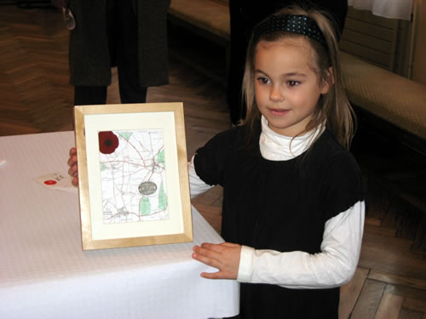
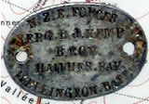
There was an interesting item on the Australian TV News the other evening. It involved the story of a six-year old French girl who found the ‘dog tag’ (military identity tag) of a WWI New Zealand soldier, while walking in former trenches in a field near her home in the Somme region. It had been lying there for over 90 years. The tag was returned to the soldier’s family. The soldier himself had survived the whole 8-9 months of the Gallipoli campaign in 1915 before being shipped to the Western Front in France, where he participated in the Battle of the Somme which began in July 1916 and cost tens of thousands of lives, 20 000 alone on just the first day! (NZ troops did not see action until two months later). The upper picture shows the tag; the lower, the girl with the tag and a map of where it was found. The man would have been with the contingent that included Nana’s uncle as after the Somme they went north to the Belgian area of Messines where the formed was wounded and sent to England to recuperate whereas Nana’s uncle was killed.

In HK, the annual HK marathon was held this morning. I have just heard on the news that it was won by a Japanese runner, the first time for some years that the winner was not from East Africa. More than 50 000 people took part, though many of these took part in the half-marathon or the 10 000-metre race rather than the full marathon.
My run yesterday was not too bad – from Tai Mei Tuk to Brides’ Pool area and to the coast and on to Luk Keng, a small village not far from the border town of Sha Tau Kok. At 2 hrs 48 mins, it was nine minutes faster than last year (which was not a good run) and four minutes faster than two years ago, which was the first time I had run this route (though the first ¾ was the same as a route I have run many times). Cool again, but good; in fact I took off my pullover at the start and ran all the way with it tied around my waist.

Also in HK, another ‘disaster’ for the Li family. This time it is about David Li, the brother (?cousin) of Arthur Li, who is the chairman of the Bank of East Asia. He has been embroiler in an insider trader scandal on the New York Stock exchanged, and paid a US$8 million ‘fine’ to settle the case rather than taking it to court. He was also a member of the HK Executive Council (i.e. Donald Tsang’s ‘cabinet’) and yesterday he resigned from the council. Several years ago, Ronald Li, another member of the family, was involved in corrupt dealings on the HK Stock Exchange.
The Super 14 competition began yesterday. Last weekend, the fourth round of the IRB World Sevens competition was held in San Diego. NZ again won this tournament, making it four wins out of four. The next tournament will be in HK, sometime in March.
That’s about it for this time.

Cheers.

